**SRI JAYACHAMARAJENDRA(Govt).POLYTECHNIC**

DEPARTMENT OF COMPUTER SCIENCE ENGINEERING

Subject : ST Theory

Topic : MAP application



From:

**Nanda Kumar**

102CS18027

6th sem

Submitted To: **Praveen kumar SIR**

**Map Software Requirements Specifications**

**Introduction**

Using current generalisation solutions, it is possible to derive a considerable range of different maps and datasets from the same database. If generalisation could be more flexible it could adapt to various needs depending on the context of use. The idea of adaptive generalisation was first studied to enable advanced location-based services . Here, maps have had to adapt to new, but well-defined parameters defining user requirements: taking account of the user’s location and mobility, the screen size and resolution, and the user’s task .

A demonstration of this was done with the first prototype of adaptive generalisation in a mobile context. Beyond location-based services, in the wider domain of web cartography, user requirements are more diverse and their description is a key research topic, as illustrated by the working groups on usability, map use and user issues (at Agile1 from 2001 to 2006, at ICA2 since 2005). On-demand mapping is the research domain that seeks to derive automatically maps tailored according to expressed user requirements.

Another challenge lies in the automatic design and orchestration of the target map’s derivation process, in particular the generalisation part of it. On-demand mapping can provide an answer to an increasingly common activity, namely creating a cartographic mash-up. A mash-up is a map combining cartographic layers from different data sources.Mash-ups are often composed of a background topographic layer (accessed through the API of a major provider such as a national mapping agency, Google or OpenStreetMap, and of a user-generated, thematic layer in the foreground. Mash-ups are prone to legibility issues for two main reasons. Firstly, since the data currently available online to the general public is not customisable, the content and legend of the background layer cannot be adapted to the foreground layer. In the example in Fig. 2.1, this results in a too dense road network and unnecessary topographic features (such as the details associated with the parks).

Key Concepts: Needs, Requirements and Specifications

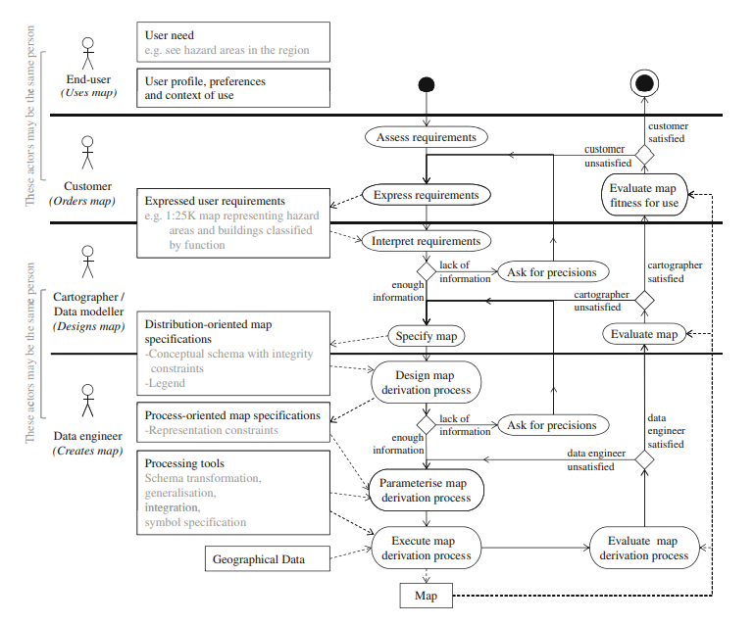

The manual process of deriving a customized map. On-demand mapping is an automatic version of this process

**User Requirements and Their Influence on Map Specifications**

As defined in Sect. 2.2.1, user requirements are a combination of user needs, user profile, preferences and a context of use. We propose to further decompose these elements into ‘‘user variables’’. Figure 2.4 synthesises common user variables and states again, the map specification elements described in Sect. 2.2.2. The needs of the user are determined by the task of the map user (e.g. ‘‘hiking’’ or ‘‘plan an itinerary’’). This task determines the map topic, which in turns influences the represented concepts and their assigned symbols. For instance, a topographic map depicts the nature of the terrain features with a ‘‘neutral’’ legend, while a navigation map focuses on and emphasises communication networks and landmarks. The needs ‘‘visualise hazard zones’’ and ‘‘perform a risk analysis’’ call for the same map topic but for different generalisation levels (potentially going up to schematic maps) and legend choices. To perform this analysis, professional users need task-specific concepts, that sometimes do not exist generically and need to be derived (Harding 2011). They also need a suitable data schema, (e.g. one with explicit network structures). There are as many classifications of user profiles (Fig. 2.4) as applications exploiting them. Users can be categorised according to their familiarity with maps (professional users, non-professional users, non-professional users who are novices in the use of maps), their age, gender and nationality. The user profile influences the level of detail of the map. For example, children or sight-deficient readers may need maps representing a limited number of concepts, a limited amount of objects with a high level of generalisation and/or large symbols.

However, the definition of what constitutes an ‘‘expert’’ and its influence over the ability to interpret maps efficiently is a controversial issue (Ooms et al. 2011). Non-professional map users may be accustomed to maps displaying many different concepts (e.g. tourist maps). The profile also influences the choice of colours. For instance, as detailed in Christophe (2009), children like primary colours and European people tend to prefer different hues from North-American people. Colour-blind users need specific colour arrangements to enhance the perceived contrast (Brewer 1997; Dhée 2011). The context of use (Fig. 2.4) refers to the place, time and situation in which the activity is carried out. If the map is needed to situate the user in a mobile context, the user’s position, and more specifically the type of place they are located in (e.g. in the underground, in the city or on the mountain), influences the choice of represented concepts. The type of media (paper or digital

map, screen size, battery life), time and season (for contrast reasons), influences the generalisation level and choice of colours, as studied by projects on ubiquitous mapping (Sarjakoski and Nivala 2005; Hoarau 2011). The situation variable may refer to ‘‘on-field study’’ versus ‘‘office study’’, ‘‘real time’’ versus ‘‘post-analysis’’, ‘‘standard’’ versus ‘‘emergency’’. As analysed by Duchêne et al. (2011), an emergency situation generates specific constraints on the map content—the message must be as simple as possible—and on the generalisation process itself—the map must be delivered quickly.

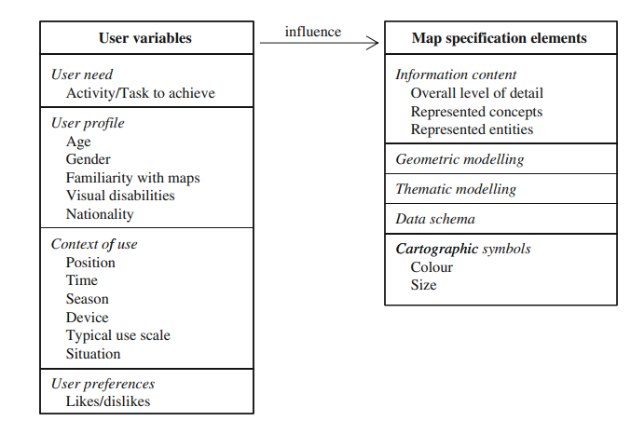User variables influencing map specification elements

**The Map Specifications Model**

The model adopted for the project relies on representation constraints, enclosing and extending the concept of cartographic constraints used for generalisation. Types of representation constraints were inspired by the model of Gesbert (2005) concerning dataset specifications. These constraints are expressed over Mapped Concepts (i.e. geographic concepts from the semantic referential) and their properties, as described by Touya and Duchêne (2011) or Zhang (2012). Figure 2.8 lists the different types of representation constraints together with examples. The model allows redundancies and correlated information: for instance, the fact that ‘‘Land cover’’ is a background mapped concept and the fact that it is represented in a faded colour can both be represented in the specifications (under symbolisation constraint), even if the latter has (or could have) been inferred from the former. The integration need is more specifically expressed through modelling and symbolisation constraints, as detailed in the next section.

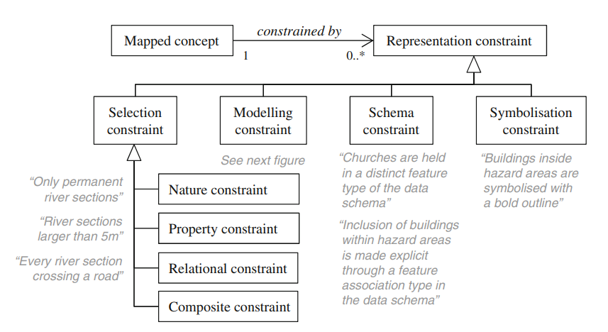

Representation constraints of the map specifications model



Symbolisation constraints (detail of the map specifications model)

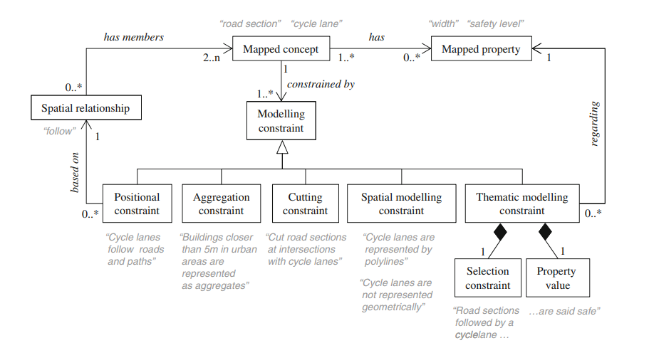

Modelling constraints (detail of the map specifications model)

**Conclusion**

Generalisation is not restricted to the production of predefined map series anymore. The current challenge is to automatically adapt to changing user requirements. This chapter presented the issues related to the creation of formal map specifications resulting from user requirements. The objectives of this research are: • to enable on-demand generalisation and on-demand mapping, resulting in good quality, usable maps that support integration of user’s data, • to make advanced mapping processes available to those users who do not have the skills to create map specifications. This chapter has shown that map usability is receiving more and more attention as the ranges of map users and map uses grow. Applications delivering maps adapted to predefined user profiles have emerged, especially in the domain of mobile maps. In parallel, map and dataset specification models have become more expressive and more interoperable. However, no global specification model to date is able to drive the entire mapmaking process. The first reason lies in the fact that on-demand mapping encompasses many processing steps. Specification models—and associated user profiles—relevant for different steps of the map-making process need to be integrated, which requires re-examination of the very concepts underlying these models. The second reason is that some of the cartographic knowledge still cannot be—and might not be in the medium term—formalised as map specifications (Stoter et al. 2009b). This should not be an obstacle to on-demand mapping. We need to consider again what we mean by map quality, in order to deliver maps that are not as ‘‘good’’ as maps involving manual editing, but are usable for a task and given context. The emergence of such specification models will lead to the issue of their instantiation, first by cartographers, and then by the end-users of the service. More formalised knowledge on map design will be required to assist these users (Ory et al. 2013). Reusable map specifications might be useful. This would assume that the specification model is shared, that specification templates are proposed, and that ‘‘map provider profiles’’ are formalised, enabling mapping agencies to retain their own trademark. The collection of user requirements and their automatic interpretation has not been sufficiently explored. Innovative interfaces based on map samples, and their associated interpretation mechanisms, have been designed for a few steps of on-demand mapping. Could the approach be extended to other steps such as content selection and user data integration? As the optimal map specifications depend on the task the user wants to achieve, task-oriented interfaces could be envisaged, as well as interfaces dedicated to users who are getting more accustomed to map-making and need to interact at different expertise levels. At each expertise level, we must decide how, and by how much, cartographic standards can incorporate user preferences.